OOP Lab: Experiment 6

Submitted By: Aryan Saxena

Batch: B1

SAP Id: 500082431

Roll No.: R214220274

**Exercise 1:** Write a Java program to implement the concept of importing classes from user defined package and created packages.

Code:

Arithmatics.java

package Mathematics;

public class Arithmatics{

    public int Add(int x, int y)

    {

        return x+y;

    }

}

Main.java

package Calculator;

import Mathematics.*;

public class Main{

    public static void main(String a[])

    {

        Arithmatics obj = new Arithmatics();

        System.out.println("5+9= " + obj.Add(5,9));

    }

}

## Output:

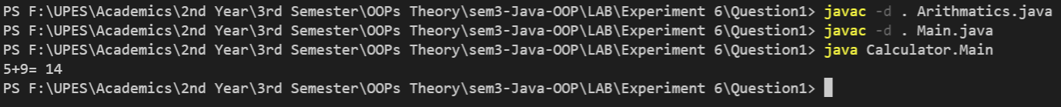

**Exercise 2:** Write a program to make a package Balance. This has an Account class with Display_Balance method. Import Balance package in another program to access Display_Balance method of Account class.

Code:

Account.java

package Balance;

public class Account {

    public void Display_Balance(float x)

    {

        System.out.println("Balance: "+ (x*100));

    }

}

Main.java

package Company;

import Balance.*;

public class Main

{

    public static void main (String[] args)

    {

        Account obj = new Account();

        obj.Display_Balance(20);

    }

}

## Output:



**Exercise 3:** WAP to create a package p with class A with 4 types of access protected methods. How we will use these methods in different packages class i.e. there is main() in class B in package Q and 4 methods are in Class A in package p.

## Code:

A.java

package p;

public class A

{

    public void Public()

    {

        System.out.println("Public!!\n");

    }

    void Default()

    {

        System.out.println("Default!!\n");

    }

    private void Private()

    {

        System.out.println("Private!!\n");

    }

    protected void Protected()

    {

        System.out.println("Protected!!\n");

    }

}

B.java

package Q;

import p.A;

public class B

{

    public static void main(String args[])

    {

        A obj = new A();

        obj.Public();

        //obj.Default(); -> Not Accessible

        //obj.Private(); -> Not Accessible

        //obj.Protected(); -> Not Accessible

    }

}

## Output:

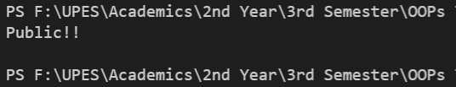

***OUTPUT with Error-* Default, Private and Protected methods are NOT accessible through package**

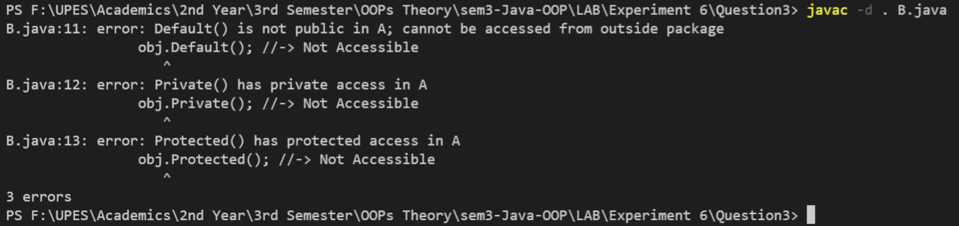

**Exercise 3:** WAP to create a package p with class A with 4 types of access protected methods. How we will use these methods in different packages class i.e. there is main() in class B in package Q and 4 methods are in Class A in package p.

## Code:

## Output: